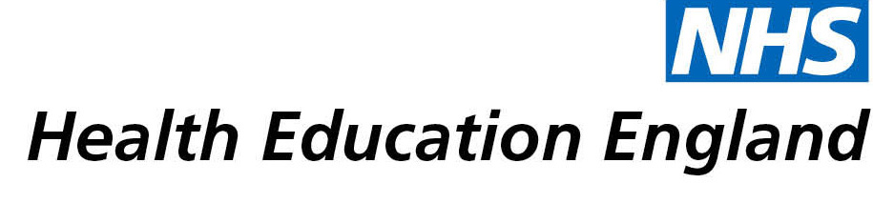

Library and Knowledge Services case study

Imperial College London / Chelsea and Westminster NHS Foundation Trust: Use of group and save blood screening

Date 15 April 2021

Reason for enquiry

We aimed to evaluate the available literature on the requirement of Group and Save (G&S) screening prior to appendicectomy and cholecystectomy. G&S is the sample processing that determines the patient blood group (ABO and RhD) and screens for any atypical antibodies. We routinely request preoperative G&S blood samples for laparoscopic/open appendicectomy and cholecystectomy. However, we set out to determine whether undertaking this prior to each procedure is necessary – is this required in terms of patient outcomes and financial implications? The primary purpose of our review was to assess the number of patients that undergo G&S testing in the relevant studies, reviewing the rate of blood transfusion, benefit on patient outcomes and the financial costs involved in this process.

What the knowledge and library specialist did

We contacted the NHS support librarian to ask for an evidence search to be conducted on the use of G&S testing prior to appendicectomy and cholecystectomy procedures. Following discussion between us and the librarian to determine the right search strategy, the search was carried out, and the results were forwarded to us.

Impact of input from the library and knowledge service
Utilising the library service in this way is a great resource, as it ensures that not only is the search itself carried out to good quality, but having the librarian undertake this part of the work we were doing took considerably less time than it might otherwise have done – our roles as clinicians mean we have much less time to devote to this aspect of our work. The search performed by the librarian is often more comprehensive and rigorous than if it was carried out by us. This helps ensure the information obtained is specific to the research question and up to date and returned to us in a very timely manner.

Immediate Impact
The primary aim of this study is to reduce emergency theatre delays in our overall practice relating to these types of surgical procedures. Other potential benefits of not performing compulsory G&S testing in every patient include time saving for staff members and reduce demand and burden on blood transfusion service.

Probable future Impact
No evidence to support that the routine use of G&S benefits patient outcomes. G&S is not necessarily required for all patients undergoing laparoscopic appendicectomy/cholecystectomy. A highly selective policy should be adopted and G&S testing should be requested on a patient case-specific basis with discussions between the surgeon and anaesthetist. This would also have financial implications to the Trust and benefit theatre resources when operations are held whilst awaiting a sample. As a result, our further aim is to look at making cost savings on these procedures in the longer term.

Submission by:
Michael G Fadel
Registrar in General Surgery
Chelsea and Westminster Hospital

For further information on how you can get similar support contact your local NHS library and knowledge service.

